

FortnaPlus Control
Conveyor Part Management
Conveyor Part Management
Document Revision: 1.1
Date: 02 July 2020

Revision | Date | Author | Revision Summary
1.0 | 07-Jun-2016 | B C Conklin | New document
1.1 | 02-Jul-2020 | T R Kremser | Updates and general refresh

Table of Contents
1. FortnaPlus Control Parts Database 4
2. Start with a View 11
3. Selecting Parts 11
4. Adding Parts 11
4.1. Add Part – Details 12
4.2. Add Part – Positioning Parts 13
4.3. Add Part – Force Part Refresh 14
4.4. Add Part – Making Curves 14
4.5. Add Part – Making Spurs 15
5. Part Types 16
6. Gen_Flag and Gen_Security 23
7. Button Example 24

Confidential/Proprietary Statement
This document contains trade secrets and information that is considered confidential and proprietary to Fortna, Inc. It may not be duplicated, used, or disclosed outside the original recipient organization, and it may not be duplicated, in whole or in part, for any purpose other than to evaluate this document. Fortna Material Handling reserves the right to modify this document as necessary to reflect any terms and conditions negotiated and included as part of a subsequent contract or purchase order.

FortnaPlus Control Parts Database
The Conveyor parts table contains all the mechanical, electrical and “memory” parts defined on the system. The Conveyor table defines how the parts are to be displayed, and their connection to IO, as well as their ownership, size, and all other attributes that define their function in the system. The contents should be identical on all Automation Controllers for a site.
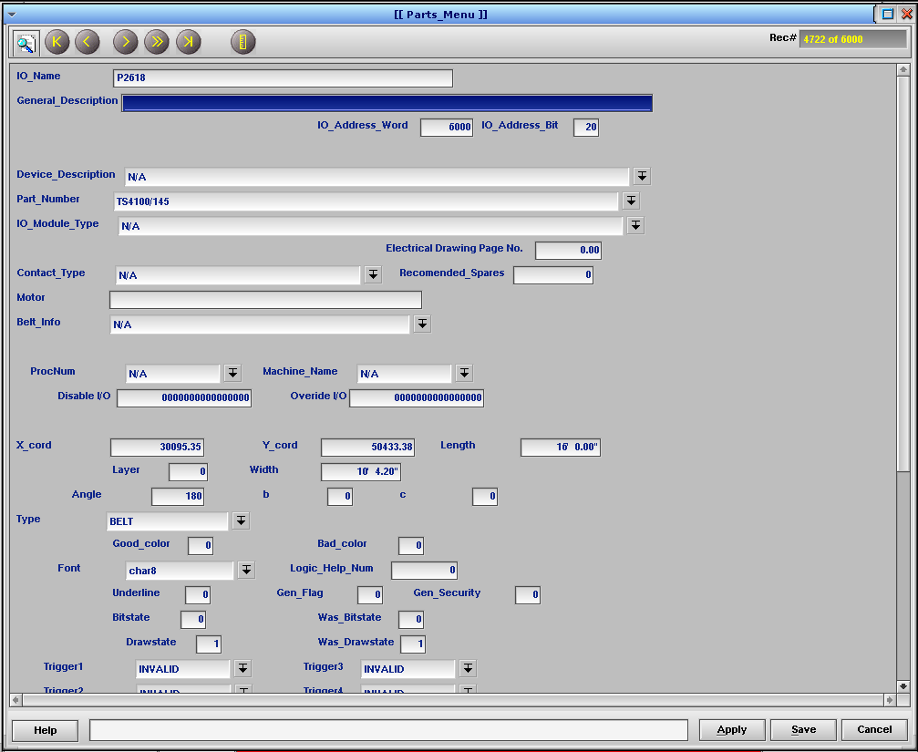

The parts database can be accessed in several ways. The Conveyor table can be opened directly at Configuration Menu | Standard Controls | IO Conveyor. It can also be accessed by clicking with the left mouse button on a part on the conveyor display to show the “Part Info” screen for the selected part, which shows a subset of the Conveyor table information. If you then click the yellow “Conveyor Menu” button, the full-blown Conveyor table will open on the record for the part you have selected.
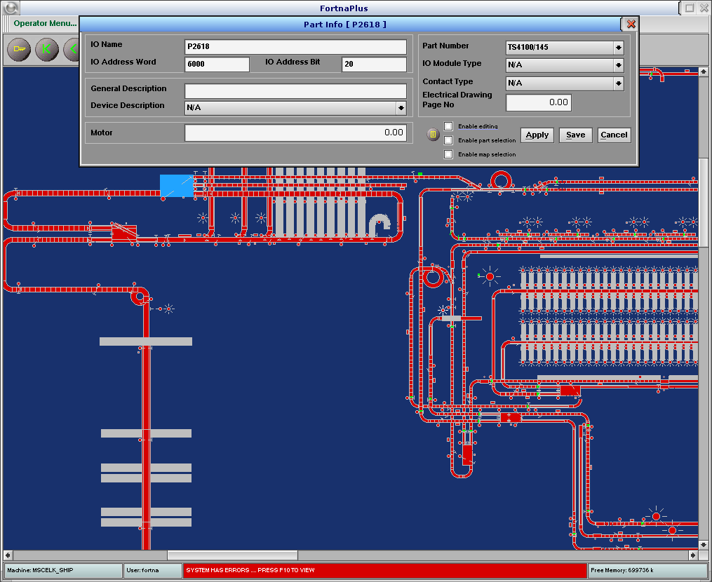

For a different subset view, right-click a part to see the “Part” screen for the selected part. The emphasis for this view is physical size and placement. Again, the full-blown Conveyor table can be opened by clicking the yellow button.
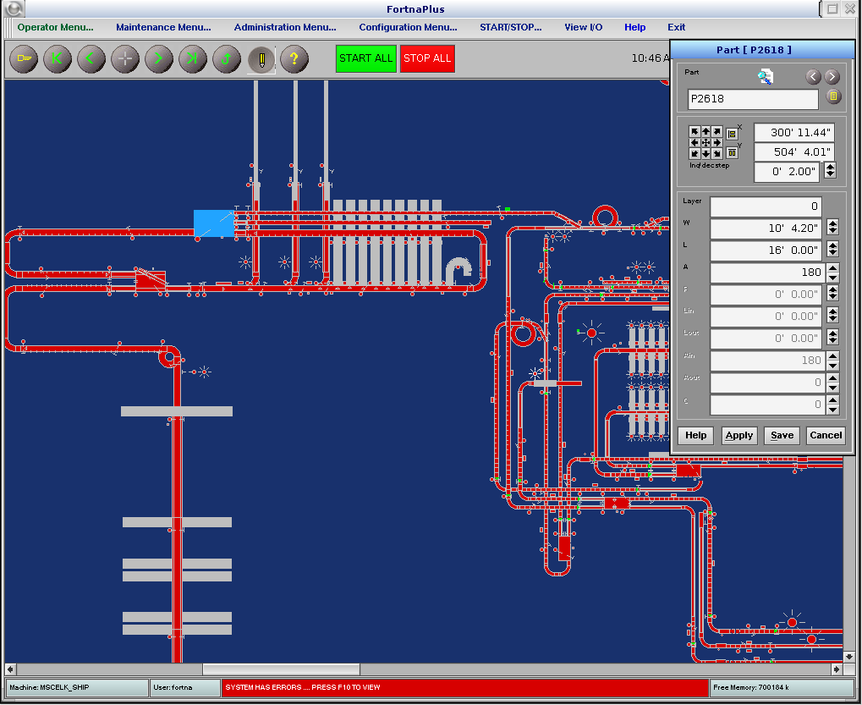
Conveyor Table
FIELD | TYPE | DESCRIPTION
IO_Name | String | Enter a unique descriptive name for the part. The part name is typically associated with the conveyor part number, or the electrical wire number and its associated function.
General_Description | String | Enter a description (optional). This field is used as a parameter for Type BUTTON parts. See the section Part Types, below, for more details
IO_Address_Word | Int | Enter the Word portion of the IO address. May be displayed in Decimal or Octal base, depending on the setting of the OCTAL_MODE flag, found in the Integer Flags table, row 101.
IO_Address_Bit | Int | Enter the Bit portion of the IO address. May be displayed in Decimal or Octal base, depending on the setting of the OCTAL_MODE flag, found in the Integer Flags table, row 101.
Device_Description | PopUp | Select a device description (optional). Items may be added to the list if not found in the PopUp.
Part_Number | PopUp | Select the part number for the device. Items may be added to the list if not found in the PopUp.
IO_Module_Type | PopUp | Select the IO module type for the device. Items may be added to the list if not found in the PopUp.
Electrical Drawing Page No. | Double | Enter the electrical drawing page number for the device.
Contact_Type | PopUp | Select the contact type. Options are Input or Output.
Recommended_Spares | Int | Enter the number of spares that should be kept on hand for this part.
Motor | String | Enter the horsepower and other motor information here.
Belt_Info | PopUp | Select the conveyor belt type. Items may be added to the list if not found in the PopUp.
Layer | Int | Enter the layer number on which to place this part. Values can be 0 through 19. The default Layer is 0. Each view may be customized to display specific layer(s) using the Layerset table and controlled through the Layerson table. THIS FEATURE IS SELDOM USED.
X_cord | Double | Enter the X coordinate of the part on the graphical layout. This determines the horizontal placement of the part. The origin is in the lower left corner.
Y_cord | Double | Enter the Y coordinate of the part on the graphical layout. This determines the vertical placement of the part. The origin is in the lower left corner.
Width | FtIn | Enter the width of the part. For conveyor parts this is the actual width of the part for the graphical layout. For other parts, see the Part Types section for more information.
Length | FtIn | Enter the length of the part. For conveyor parts this is the actual length of the part for the graphical layout. For other parts, see the Part Types section for more information.
Angle | Int | Enter the angle, in degrees, to determine how to rotate the part for the conveyor layout. Zero is to the right, 90 is straight up. If the part is a curve, this will be the starting angle for the infeed.
Type | PopUp | Select a Type from the list. Various part types are pre-defined, such as PHOTOCELL, MOTOR, and BELT. Each type may have specific additional features that define how the values in other fields in this table are treated. See section Part Types, below, for additional detail.
c | Int | Parameter used for specific part Types. See the Part Types section for more information.
b | Int | Parameter used for specific part Types. See the Part Types section for more information.
Good_color | Int | Set by the software.
Bad_color | Int | Set by the software.
Font | PopUp | Select the font for part Types such as a TITLE or LABEL. The text that is entered in the Motor field will be displayed in the selected font. For the TEXT Type, the font is selected based on the current zoom level. See the Part Types section for more information.
Underline | Int | Set by the software.
Logic_Help_Num | Int | Set by the software. Shows the first help line that lists this part.
Gen_Flag | Hex | Set this value to modify the normal behavior for a part. There are many options. See section Gen_Flag and Gen_Security for details. Gen Gladchun was an evil genius!
Bitstate | Int | Set by the software.
Was_Bitstate | Int | Set by the software.
Drawstate | Int | Set by the software.
Was_Drawstate | Int | Set by the software.
Trigger1 | PopUp | Unused.
Trigger2 | PopUp | Unused.
Trigger3 | PopUp | Unused.
Trigger4 | PopUp | Unused.
ProcNum | PopUp | Select the process that owns the IO for this part. For IO controlled by a sorter, select SORT. For all other IO, select CTRL.
Speed | Int | Enter the speed of the conveyor part in feet per second, if applicable.
Machine_Name | PopUp | Select the Machine that will control this part.
TriggerLink_Name | String | Not used.
TriggerLink_NDX | Int | Not used.
Disable I/O | FortnaInt | Set by the software. Stores the disable bits for the part. There are sixteen bits available. If any bit is high (1) the IO is disabled. The software will set the bits for Full and Jam conditions. Other modules and triggers may also use this field to set or clear disable bits.
Overide I/O | FortnaInt | Set by the software. Stores the override bits for the part. There are sixteen bits available. When set, the system will ignore the stop bit and will continue running.
Drive | String | A place to record the drive unit information, if needed.
NoseOver | String | A place to record the noseover style information, if needed.
Infeed_Elevation | FtIn | A place to record the conveyor infeed elevation, if needed.
Discharge_Elevation | FtIn | A place to record the conveyor discharge elevation, if needed.
Belt_Width | FtIn | A place to record the conveyor belt width, if needed.
Infeed_Tangent | FtIn | Enter the length of the tangent installed on the infeed end of a curve or spur. See the Part Types section for more information.
Discharge_Tangent | FtIn | Enter the length of the tangent installed on the discharge end of a curve or spur. See the Part Types section for more information.
Roller_Centers | FtIn | A place to record the center-to-center spacing for roller conveyor parts.
Tapered_Rollers | Y/N | A place to record if the part uses tapered rollers.
Supports | String | A place to record information about the conveyor supports.
Inside_Radius | FtIn | Enter the inside radius of a curve.
Price | String | A place to record the price for a part.
Default Colors | PopUp | Select the Colorset. This will determine the colors used to display the part in the ON and OFF state.  NOTE: The color may be overridden by certain modules like Mtrchains, Fullline or Jamcheck. A conveyor section’s color may be determined by the state of a motor or photo eye associated with it through one or more of those modules.
In Motor Chain | Y/N | Set by the software. Indicates if the part is found in the Mtrchain table.
Important_IO | Y/N | Set by the software for IO in tables EStop, Mtrchain, BeaconInfo, LiftGatesCtrl, and horns. The states of these parts are distributed to other nodes more frequently.
ErrLink | Int | Set by the software in conjunction with the Errors_ScrnIO feature. Used to define the error message currently linked to this part. One or more errors may be linked to a TITLE or TEXT part for display on the GUI screen. The Errors Description field is copied to the Motor field of the ScrnIO part when the error is activated. If multiple errors are active at the same time, the oldest one wins.  The Errors table ScrnIO column is used to select an IO part that will be turned ON or OFF with the error.  The GUI process controls the Errors module, so the IO selected in ScrnIO must be owned by GUI.
ErrTime | Int | Set by the software in conjunction with the Errors_ScrnIO feature.
Gen_Security | Int | Double-click this field to open the Role Editor view. Choose the roles that should have access to BUTTON parts defined using the Gen_Flag = 2 IO Force feature. See section Gen_Flag and Gen_Security for details.

Start with a View
The background color of the graphics screen is controlled by the selected view. The color of each view is found in table PhView. A default view called “The whole conveyor” is provided when creating a new system. The default may be modified, and additional views may be created, as needed. Set the Fill color to change the background color.

Selecting Parts
Parts may be selected by dragging a box around them while holding the right mouse button. A single part may be selected by clicking with the right mouse button.
If multiple parts are selected, instead of the part name, the quantity of parts will be displayed in the Part Editor window dialog box, with “Group:”. You may add parts to or remove parts from the group by holding Shift while right-clicking them.
You may select different parts by right-clicking or right-clicking and dragging while the Part Editor window is open without having to close it first.

Adding Parts
A valid part requires, at minimum, a name (IO_Name) and an IO address (IO_Address_word and IO_Address_Bit). Some parts (notably, the “P” parts like Type BELT, STRAIGHT, CURVE and Type TEXT parts, for example) are used for display on the screen and do not have real IO addresses. They are configured with an invalid IO address. The exact values for the invalid address vary depending on the OCTAL_MODE flag setting (Integer Flags number 101) and the maximum IO value defined for the version of software. To find the proper values, look at the “zeroth” part – INVALID – which is automatically configured by the software. Currently, the values are word: 6000 Octal / 3072 Decimal, and bit: 20 Octal / 16 Decimal.
New parts are usually added just before the END marker part (though they could be added anywhere before the END marker). To find the END marker in the Conveyor table, click the  button. While the END part is displayed, use Alt-I to insert a blank record. The new record will be inserted just before the END marker. Be sure to fill in at least the minimum fields after creating a new record, as the software will stop scanning the table at a blank record, or the END marker, whichever comes first.

Add Part – Details
- Create a blank record.
- Fill in the IO_Name, IO_Address_Word and IO_Address_Bit.
- Fill in the General_Description field (usually optional).
- Enter the Layer for the part. Most likely, this will be zero.
- The X_cord and Y_cord values will be set later as the part is positioned on screen.
- Fill in the Width and Length fields. Enter the values as feet and inches. You can enter just feet or just inches, as well. Example: 6’ 3” (six feet, three inches). When you click Apply, the field will be re-formatted in the correct notation. For a curve, set the Length to 1 or -1 depending on the direction of the curve (Notice these values are NOT in feet and inch notation. See the section Add Part – Making Curves for details).
- Enter the Angle in degrees. Zero is straight to the right, 90 degrees is straight up, and so on. The angle is based on the direction of travel, so if a conveyor section is to carry product from left to right, its Angle would be 0. If it is to carry product from right to left, its Angle would be 180. For curves, the Angle is relative to the infeed end.
- Choose a Type from the list. For conveyor parts, the options are STRAIGHT, CURVE, BELT or ZEROPRESSURE. See the Part Types section for more information.
- The Drive, NoseOver and Supports fields may be filled in but are not required. If the part is a CURVE that has tangents, the Infeed_Tangent and Discharge_Tangent lengths must be specified.
- The Inside_Radius field must be completed for a CURVE. The value can be found on the mechanical drawings or order entry sheets.
- For CURVE parts, the field named b must be completed to define the direction of the curve. For example, if the curve is to go from left to right, then curve upward, the Angle field would be set to 0, and the b field would be set to 90.
- Set the Default_Colors field to CONV_RUNNING.

Add Part – Positioning Parts
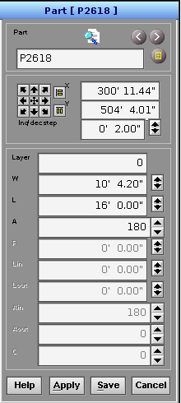
The items in the lower portion of the Part Editor window provide a different view of fields in the Conveyor table. They can be used to inspect or alter the values just as they can through the table, though they use shorthand names to conserve space. The fields are also context-sensitive, so they may be greyed-out depending on the Type selected for the part. Layer = Layer, W = Width, L = Length, A = Angle (for parts other than CURVE or SPUR), R = Inside_Radius, Lin = Infeed_Tangent, Lout = Discharge_Tangent, Ain = Angle (for CURVE and SPUR), Aout = b, C = c.
    - Right-click a part to open the Part Editor view.
    - Move the part using the mouse by holding the right button and dragging. For finer adjustments, use the controls in the Part Editor window just below the part name. You can enter a position directly in feet and inches or use the arrow buttons to move the part in the desired direction. Adjust the increment for each button click in the inc/dec step box. The Width, Length and Angle values can also be adjusted here, if needed.
    - Multiple parts can be selected and moved together. Select a single part, as described above, then hold Shift and right-click to add (or remove) parts. They will all be highlighted in blue and they will all move together. You can also select a block of parts by right-click and drag to define a rectangle. All parts completely or partially inside the rectangle will be selected. You can then add or remove parts from the set using Shift and right-click.
    - For parts such as photo eyes and solenoids, the Angle may need to be adjusted to orient the symbol in a way that makes sense. The Length and Width may also be adjusted to make the symbol appropriately visible.

Add Part – Force Part Refresh
A part’s appearance on the screen is refreshed whenever an event occurs that affects its color. Events might include a motor start/stop, a full condition occurring or clearing, or an EStop occurring or clearing. Only the affected parts are re-drawn – the entire screen is not refreshed. If a part has the “flash” attribute set, it will be updated with each flash. The flash attribute can be used to cause the entire screen to refresh, as described in the following example. It will create a new flashing color that is almost an exact match for the background color “Dusty Blue”. The flash attribute will force refresh of the conveyor parts.
Example:
- Choose an unused row in the Colors table and define a new color. Unused rows will be named with a “c” and the row number. Name the new row “DustyBlue2”, with values of R = 25, G = 49, B = 109.
- Choose an unused row in the Colorset table and define “DustyBlueFlash” with Outline = “Dusty Blue”, Fill = “DustyBlue2” and Flash = Y.
- Choose an unused row in the Convclr table and define “DustyBlueFlash” with ColorSetOn, ColorSetOff and ColorsetHtrOff set to “DustyBlueFlash”.
- Create a part in table Conveyor that is behind all other parts and set its Default Colors value to “DustyBlueFlash”.

Add Part – Making Curves
These steps define how to make a curve. Spurs are slightly different and are described in the next section.
- Create the curve part and give it a valid IO_Name.
- Set a Width value consistent with the width of the other conveyor parts.
- Set the infeed Angle (a.k.a., Ain). This defines the direction the product will be traveling as it enters the curve. 0 = left to right, 90 = bottom to top, 180 = right to left, 270 = top to bottom.
- Set the outfeed angle in b (a.k.a., Aout). This defines the direction the product will be traveling as it exits the curve.
- Set the Length. Look at the Angle and b values and determine if the curve is to the left or right by following the product flow from the direction defined by Angle to the direction defined by b. For a left curve, enter 1 and click Apply, which will display as 0’ 0.12”. For a right curve, enter -1 and click Apply, which will display as 0’ -0.12”.
- Select CURVE from the list in the Type field.
- Set the Inside_Radius value. The correct value can be found in the drawings. A radius of 3’ will work as a starting point in most cases if the value is unknown.
- Save the part and position it as needed.

Add Part – Making Spurs
A spur looks like a combination of a straight section and a curve. It has two infeeds and one outfeed. A spur is made in the same way as a curve with a few additional components.
- Use Type of SPUR instead of CURVE.
- Set up Angle (a.k.a., Ain) and b (a.k.a., Aout) as for a curve, but adjust the value for b. For a left spur, subtract the angle of the spur from Aout (found in the drawings, usually 30, 45 or 60 degrees). For a right spur, add the angle of the spur to Aout.
- Set the Infeed_Tangent length (a.k.a., Lin) and the Discharge_Tangent length (a.k.a., Lout). These values are required for a spur. They can be found in the drawings.
Example Spurs:
Right, 60°
Len: -1
Ain: 0
Aout: 330
Lin: 2’
Lout: 2’
Right, 60°
Len: -1
Ain: 180
Aout: 150
Lin: 2’
Lout: 2’
Left, 60°
Len: +1
Ain: 0
Aout: 30
Lin: 2’
Lout: 2’
Left, 60°
Len: +1
Ain: 180
Aout: 210
Lin: 2’
Lout: 2’

Right, 60°
Len: -1 Lin: 2’
Ain: 90 Lout: 2’
Aout: 60
Left, 60°
Len: +1 Lin: 2’
Ain: 270 Lout: 2’
Aout: 300
Left, 60°
Len: +1 Lin: 2’
Ain: 90 Lout: 2’
Aout: 120
Right, 60°
Len: -1 Lin: 2’
Ain: 270 Lout: 2’
Aout: 240

Part Types
The Type field in table Conveyor defines the appearance, behavior, and requirements for entries in other fields. Some important types have been described in detail, above. This table contains additional details on all of the types.
Index | Type | DESCRIPTION
0 | INVALID | Select this if the record is not used.
1 | STRAIGHT | Straight – Draw a straight conveyor section.  - X_cord, Y_cord  - Width  - Angle  - Default Colors – Set Text color, Fill color  - Image is scaled based on zoom level.
2 | CURVE | Curve – Draw a curve. See section Add Part – Making Curves  - X_cord, Y_cord  - Width  - Length – Sets the curve direction (+1, -1)  - Inside_Radius  - Angle – Infeed angle.  - b – Outfeed angle.  - Infeed_Tangent  - Outfeed_Tangent  - Default Colors – Set Text color, Fill color  - Image is scaled based on zoom level.
3 | BEACON | Beacon – Draw a beacon  - X_cord, Y_cord  - Width – Sets the diameter.  - Default Colors – Set Text color, Fill color  - Image is scaled based on zoom level.
4 | LABEL | Not Implemented
5 | PROXPART | ProxPart – Draw a proximity switch  - X_cord, Y_cord  - Width – Sets the diameter.  - Default Colors – Set Text color, Fill color  - Image is scaled based on zoom level.
6 | FONT | Not Implemented
7 | TITLE | Title – Draw a text title  - X_cord, Y_cord  - Motor – Sets title text.  - Font – Sets the text font.  - Default Colors – Sets the text color. If different colors are needed, select a Colorset where the foreground color is not the same as background color. Good choices include Nice Title or SCREEN TITLE. Background color is set by changing the Fill color in the popups from Colorset On and Colorset Off.  - Text is not scaled with the zoom level!  Note: If you want the text to disappear when the IO is OFF, right-click on the arrow by Default Colors. Add “Title OnOff”, select “Colorset On” of “CONV_BLUE”. Select “Colorset Off” of “Estops”.
8 | SPUR | Spur – Draw a spur. See section Add Part – Making Spurs  - X_cord, Y_cord  - Width  - Length – Sets the spur direction (+1, -1)  - Inside_Radius  - Angle – Infeed angle. (a.k.a., Ain)  - b – Outfeed angle. (a.k.a., Aout)  - Infeed_Tangent – Length of infeed (a.k.a., Lin)  - Discharge_Tangent – Length of outfeed (a.k.a., Lout)  - Default Colors – Set Text color, Fill color  - Image is scaled based on zoom level.
9 | TEXT | Text – Draw a scalable title  - X_cord, Y_cord  - Motor – Set the displayed text.  - Font – Sets display font. Enable for each zoom level in table TextFontZoom (modern versions, at least).  - Default Colors – Sets the text color. If different colors are needed, select a Colorset where the foreground color is not the same as background color. Good choices include Nice Title or SCREEN TITLE. Background color is set by changing the Fill color in the popups from Colorset On and Colorset Off.  - Text is scaled based on the zoom Level.  Note: If you want the text to disappear when the IO is OFF, right-click on the arrow by Default Colors. Add “Title OnOff”, select “Colorset On” of “CONV_BLUE”. Select “Colorset Off” of “Estops”.
10 | SPARE | Not Implemented
11 | TRIANG | Triangle – Draw a triangle  - X_cord, Y_cord  - Width – Set the length of the first leg.  - Length – Set the length of the second leg.  - Angle – Set the orientation.  - Default Colors – Set Text color, Fill color  - Image is scaled based on zoom level.
12 | PB32HQ | Not Implemented
13 | PB16HQ | Not Implemented
14 | PHOTOCELL | Photocell – Draw a photo cell  - X_cord, Y_cord  - Width – Set the diameter.  - Length – Set the distance to the reflector.  - Angle – Set the orientation.  - Default Colors – Set Text color, Fill color  - Image is scaled based on zoom level.
15 | MOTOR | Motor – Draw a motor (Appears as a circle with two tangent lines)  - X_cord, Y_cord  - Width – Set the diameter.  - Angle – Set the orientation.  - Default Colors – Set Text color, Fill color  - Image is scaled based on zoom level.
16 | BELT | Belt – Draw a conveyor belt  - X_cord, Y_cord  - Width  - Length  - Angle  - Default Colors – Set Text Color, Fill Color  - Image is scaled based on zoom level.
17 | HORN | Not Implemented
18 | DASHLINE | DashLine – Draw a dashed line  - X_cord, Y_cord  - Length  - Angle  - Default Colors – Set Fill color  - Image is scaled based on zoom level.
19 | CAMERA | Not Implemented
20 | ZEROPRESSURE | ZeroPressure – Draw a zero-pressure conveyor section if c (zone size) is defined, Draw a straight conveyor section otherwise.  - X_cord, Y_cord  - Width  - Length  - Angle  - b – Set the number of zones.  - c – Set the zone size in inches. Or…  - Underline – Set the zone size in pixels.  - Default Colors – Set Text color, Fill color  - Image is scaled based on zoom level.
21 | FF | Not Implemented
22 | ANIMATE | Not Implemented
23 - 24 |  | Not Implemented
25 | ZOOMBOX | ZoomBox – Draw a View selection box.  - X_cord, Y_cord  - Width – Set the box width.  - Length – Set the box length.  - Motor – Set the name of View to display when clicked.  - Font – Sets display font. Enable for each zoom level in table ViewFontZoom (modern versions, at least).  - Angle – Set the orientation.  - Default Colors – Set Text color, Fill color  - Image is scaled based on zoom level.  Note: The box needs to be large enough to hold the text. Navigate away from the object to view. Selected foreground color is the same as selected background (ColorsGUI table).  Note: De-select the “pencil” editing icon to enable the click event.
26 - 29 |  | Not Implemented
30 | MENU INVISIBLE | Not Implemented
31 | MENU STRAIGHT | Not Implemented
32 | MENU CURVE | Not Implemented
33 | MENU BEACON | Not Implemented
34 | MENU LABEL | Not Implemented
35 | MENU PROXPART | Not Implemented
36 | MENU FONT | Not Implemented
37 | MENU TITLE | Not Implemented
38 | MENU MFONT | Not Implemented
39 | MENU TEXT | Not Implemented
40 | MENU MMENU | Not Implemented
41 | MENU TRIANGLE | Not Implemented
42 | MENU PB32HQ | Not Implemented
43 | MENU PB16HQ | Not Implemented
44 | MENU PHOTOCELL | Not Implemented
45 | MENU MOTOR | Not Implemented
46 | MENU BELT | Not Implemented
47 | MENU HORN | Not Implemented
48 - 59 |  | Not Implemented
60 | DATA_PROMPT | Not Implemented
61 | DATA_DATA | Not Implemented
62 | IMAGE | Image – Load an image from RUN/IMAGES  - X_cord, Y_cord  - General_Description – Name of the image file to open.  - Image is scaled based on zoom level.  Note: Use an image editor to adjust the image size to around 200 x 200 pixels for best results.
63 | BUTTON | Button – Draw a clickable button.  - X_cord, Y_cord  - Width – Set the button height.  - Length – Set the button width (yeah, that’s right – try it!).  - General_Description – Set the name of the table or menu to open (If Gen_Flag is 0).  - Motor – Set the name of the button. Enter only a few characters to make sure the text fits before entering the entire name. The text will not display if it does not fit.  - Font – Sets display font. Enable for each zoom level in table ButtonFontZoom or it will not display (modern versions, at least).  - b – Set by the software. Contains 1 when the button is pressed, 0 otherwise.  - Default Colors – Set Text color, Fill color – Nice Title and SCREEN TITLE are good choices.  - Image is scaled based on zoom level.  Note: If Gen_Flag is not 0 (or negative, or 2, 5, 6 or 99), the button will execute a procedure instead of opening a table or menu. The procedure name is set in General_Description. See section Gen_Flag and Gen_Security for more details.  Note: If Gen_Flag is 2, the IO will be toggled (using a FORCE) with each press of the button. The Gen_Security field is used to assign security roles to the button, but only for the IO toggle feature. Double-click the field to open the Role Editor window. Select the roles that will be allowed access to the button. If Gen_Security is set to 0, then anyone can click the button.  Note: The button needs to be large enough to hold the text, or it will not display. Navigate away from the object to view. Select a Colorset where the foreground color is not the same as background color for best results. Good choices are Nice Title or SCREEN TITLE.  Note: De-select the “pencil” editing icon to enable the click event.
64 | FIELD | Field – Draw a dynamic text field  - X_cord, Y_cord  - General_Description – Set the text to be displayed. The text will update on screen if it is changed.  - Angle  - Font – Sets display font. Enable for each zoom level in table FieldFontZoom or it will not display (modern versions, at least).  - Default Colors – Set Text color, Fill color  - Image is scaled based on zoom level.
65 | OPEN MENU | Not Implemented
66 | HELPBUTTON | Not Implemented
67 | COLUMN LINE | Column – Draw a column line  - X_cord, Y_cord  - Angle  - Width – Diameter of the column  - Length – Distance to small solid circle  - Default Colors – Set Text color, Fill color  - Image is scaled based on zoom level.
68 - 69 |  | Not Implemented

Gen_Flag and Gen_Security
The Gen_Flag field influences the behavior of various part types. Set this value to modify the normal behavior for a part. There are many options.
Gen_Flag | Type | Behavior
< 1 | Any except  65: OPEN MENU  (so Any) | Alters part dragging behavior
0 | Any except  63: BUTTON | Default behavior
0 | 63: BUTTON | Opens the table or menu defined in General_Description.
!= 0 | 63: BUTTON | Executes the procedure named in General_Description
2 | 63: BUTTON | Toggles the part ON or OFF with each click using a Force. Use the Gen_Security field to control access to the button by user role. Double-click the Gen_Security field to open the role editor dialog. Choose any roles that should be allowed access.
5 | Any | Causes the procedure named in the Motor field to be executed while in edit mode.
6 | Any | Causes info about a TrilogySet named in the Motor field to be copied to the General_Description field while in edit mode.
99 | Any | Modifies the behavior with respect to calling procedures. It prevents a procedure from being called when the part is clicked. The procedure name that would have been called is defined in the General_Description field – not that it matters.

Button Example
Add some conveyor parts to scale the picture:
- Add the first part to the Conveyor table:
  - IO_Name – P108
  - X_cord – 305’
  - Y_cord – 176’
  - Length – 108’
  - Width – 3’ 0.00”
  - Type – STRAIGHT
  - Angle - 0
- Add the second part to the Conveyor table:
  - IO_Name – P109
  - X_cord – 299’
  - Y_cord – 150’
  - Length – 20’
  - Width – 3’ 0.00”
  - Type – STRAIGHT
  - Angle – 90
- Add the button
  - IO_Name – Button
  - Motor – Tray Errors (text displayed on the button)
  - X_cord – 341’
  - Y_cord – 125’
  - Length – 19’
  - Width – 4’ 0.00”
  - Type – BUTTON
  - Width – Width of the box
  - Length – Length of the box.
  - General_Description – Errors (name of the table or menu to open)
  - Font – Choose the font for the button. Be sure to enable that font in table ButtonFontZoom for all the desired zoom levels.
  - b – Set by the software to show the current state of the button (1 = pressed, 0 = not pressed)
  - Default Colors – Set the Text color and Fill color by selecting a Colorset such as Nice Title or SCREEN TITLE

